**UNIVERSITY INSTITUTE OF COMPUTING**

**CASE STUDY REPORT**

**ON**

**PARTICULAR CASE STUDY**

Program Name: BCA

Subject Name/Code: Database Management System (23CAT-251)

**Submitted by: Submitted to:**

**Name:** Rajan Pal **Name: Arvinder Singh**

**UID:** 23BCA10344 **Designation: Assistant Professor**

**Section: 23BCA-4-B**

ABSTRACT

* INTODUNCTION:
* TECHNIWUE:
* SYSTEM CONFIGURATION:
* INPUT:
* ER DIAGRAM:
* TABLE REALTION:
* TABULAR FORMAT:
* TABLE CREATION:
* SQL QUERIES WITH OUTPUT (at least 10 to 15 ):
* SUMMARY:
* CONCLUSION:

**Library Management System - Case Study**

**1. INTRODUCTION**

Libraries have evolved from physical repositories of books to comprehensive digital and physical hubs for information and knowledge sharing. The modern-day library system not only manages books but also handles user registrations, borrowing and return systems, penalties, and availability statuses. This case study presents a Library Management System (LMS) built using MySQL, focusing on streamlining the operations involved in managing books, authors, members, loans, and fines.

**2. TECHNIQUE**

The LMS leverages the Relational Database Management System (RDBMS) approach. Data normalization, referential integrity, and indexing techniques have been used to create an efficient and scalable database. MySQL was chosen for its robustness and open-source nature. SQL (Structured Query Language) is used extensively for data manipulation and retrieval.

**3. SYSTEM CONFIGURATION**

* Operating System: Windows 10 / Ubuntu 20.04+
* RDBMS: MySQL 8.0+
* Tools: MySQL Workbench / phpMyAdmin
* RAM: Minimum 4 GB
* Processor: Intel i3 or higher

**4. INPUT**

Inputs to the LMS include:

* Member data (name, contact details, membership type)
* Author information (name, nationality, birth/death years)
* Book metadata (title, author, publication year, genre, etc.)
* Loan transactions (book issued, due date, return date)
* Fine data (fine amount, status, date paid)

**5. ER DIAGRAM DESCRIPTION**

Entities:

* **Members**: Tracks library users
* **Authors**: Stores author information
* **Books**: Represents available books
* **Loans**: Keeps record of borrowings
* **Fines**: Maintains penalty details

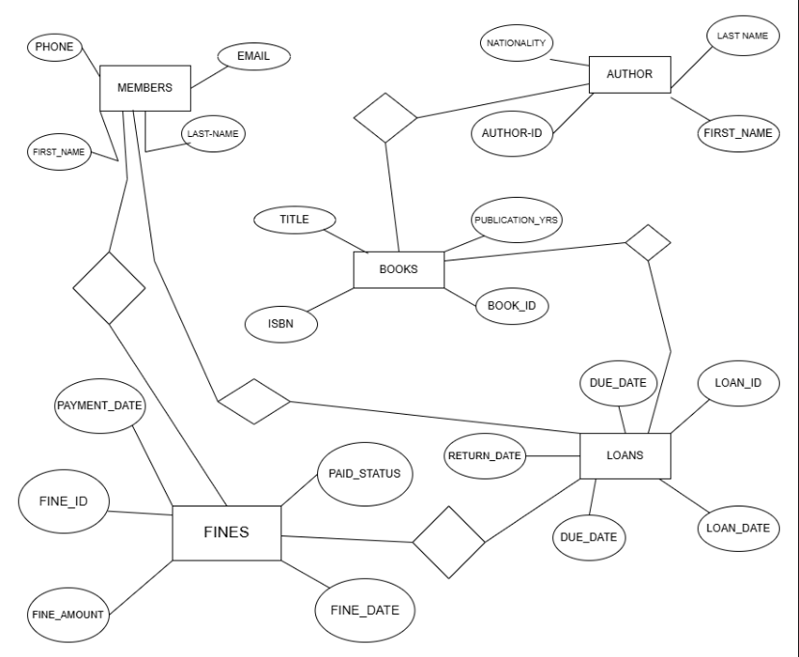

Relationships:

* One **Author** can write many **Books** (1:M)
* One **Member** can have multiple **Loans** (1:M)
* One **Loan** can generate a **Fine** (1:1)
* One **Book** can be loaned multiple times (1:M)

**6. TABLE RELATIONSHIPS**

* **Members** (member_id) → **Loans** (member_id)
* **Authors** (author_id) → **Books** (author_id)
* **Books** (book_id) → **Loans** (book_id)
* **Loans** (loan_id) → **Fines** (loan_id)
* **Members** (member_id) → **Fines** (member_id)

**7. TABULAR FORMAT**

| **Table** | **Description** |
| --- | --- |
| Members | Stores user details |
| Authors | Information about book authors |
| Books | Metadata and availability of books |
| Loans | Transaction history of issued books |
| Fines | Fine imposition and payment records |

**8. TABLE CREATION**

Tables are created using CREATE TABLE statements with primary keys, foreign keys, and data integrity constraints.

(Refer to the code section for actual SQL)

**9. CODE**

**-- Create database and use it**

**CREATE DATABASE LibraryManagement;**

**USE LibraryManagement;**

**-- 1. Members table**

**CREATE TABLE Members (**

**member_id INT PRIMARY KEY AUTO_INCREMENT,**

**first_name VARCHAR(50) NOT NULL,**

**last_name VARCHAR(50) NOT NULL,**

**email VARCHAR(100) UNIQUE,**

**phone VARCHAR(15),**

**address VARCHAR(200),**

**join_date DATE NOT NULL,**

**membership_type ENUM('Student', 'Adult', 'Senior', 'Child') NOT NULL,**

**active_status BOOLEAN DEFAULT TRUE**

**);**

**-- 2. Authors table**

**CREATE TABLE Authors (**

**author_id INT PRIMARY KEY AUTO_INCREMENT,**

**first_name VARCHAR(50) NOT NULL,**

**last_name VARCHAR(50) NOT NULL,**

**nationality VARCHAR(50),**

**birth_year INT,**

**death_year INT**

**);**

**-- 3. Books table**

**CREATE TABLE Books (**

**book_id INT PRIMARY KEY AUTO_INCREMENT,**

**title VARCHAR(200) NOT NULL,**

**author_id INT NOT NULL,**

**isbn VARCHAR(20) UNIQUE,**

**publication_year INT,**

**genre VARCHAR(50),**

**publisher VARCHAR(100),**

**total_copies INT DEFAULT 1,**

**available_copies INT DEFAULT 1,**

**shelf_location VARCHAR(20),**

**FOREIGN KEY (author_id) REFERENCES Authors(author_id)**

**);**

**-- 4. Loans table**

**CREATE TABLE Loans (**

**loan_id INT PRIMARY KEY AUTO_INCREMENT,**

**book_id INT NOT NULL,**

**member_id INT NOT NULL,**

**loan_date DATE NOT NULL,**

**due_date DATE NOT NULL,**

**return_date DATE,**

**FOREIGN KEY (book_id) REFERENCES Books(book_id),**

**FOREIGN KEY (member_id) REFERENCES Members(member_id)**

**);**

**-- 5. Fines table**

**CREATE TABLE Fines (**

**fine_id INT PRIMARY KEY AUTO_INCREMENT,**

**loan_id INT NOT NULL,**

**member_id INT NOT NULL,**

**fine_amount DECIMAL(10,2) NOT NULL,**

**fine_date DATE NOT NULL,**

**paid_status BOOLEAN DEFAULT FALSE,**

**payment_date DATE,**

**FOREIGN KEY (loan_id) REFERENCES Loans(loan_id),**

**FOREIGN KEY (member_id) REFERENCES Members(member_id)**

**);**

**-- Insert sample data into Authors table**

**INSERT INTO Authors (first_name, last_name, nationality, birth_year, death_year) VALUES**

**('J.K.', 'Rowling', 'British', 1965, NULL),**

**('George', 'Orwell', 'British', 1903, 1950),**

**('Harper', 'Lee', 'American', 1926, 2016),**

**('J.R.R.', 'Tolkien', 'British', 1892, 1973),**

**('Agatha', 'Christie', 'British', 1890, 1976),**

**('Stephen', 'King', 'American', 1947, NULL),**

**('Jane', 'Austen', 'British', 1775, 1817),**

**('Leo', 'Tolstoy', 'Russian', 1828, 1910),**

**('Mark', 'Twain', 'American', 1835, 1910),**

**('Ernest', 'Hemingway', 'American', 1899, 1961),**

**('F. Scott', 'Fitzgerald', 'American', 1896, 1940),**

**('Virginia', 'Woolf', 'British', 1882, 1941),**

**('Charles', 'Dickens', 'British', 1812, 1870),**

**('Gabriel', 'García Márquez', 'Colombian', 1927, 2014),**

**('Toni', 'Morrison', 'American', 1931, 2019);**

**-- Insert sample data into Members table**

**INSERT INTO Members (first_name, last_name, email, phone, address, join_date, membership_type) VALUES**

**('John', 'Smith', 'john.smith@email.com', '555-0101', '123 Main St, Anytown', '2020-01-15', 'Adult'),**

**('Emily', 'Johnson', 'emily.j@email.com', '555-0102', '456 Oak Ave, Somewhere', '2021-03-22', 'Adult'),**

**('Michael', 'Williams', 'mike.w@email.com', '555-0103', '789 Pine Rd, Nowhere', '2019-11-05', 'Senior'),**

**('Sarah', 'Brown', 'sarah.b@email.com', '555-0104', '321 Elm St, Anywhere', '2022-02-18', 'Adult'),**

**('David', 'Jones', 'david.j@email.com', '555-0105', '654 Maple Dr, Everywhere', '2020-07-30', 'Adult'),**

**('Jennifer', 'Garcia', 'jenn.g@email.com', '555-0106', '987 Cedar Ln, Somewhere', '2021-09-14', 'Adult'),**

**('Robert', 'Miller', 'rob.m@email.com', '555-0107', '135 Birch Blvd, Nowhere', '2018-05-21', 'Senior'),**

**('Lisa', 'Davis', 'lisa.d@email.com', '555-0108', '246 Walnut Way, Anywhere', '2022-01-10', 'Adult'),**

**('Thomas', 'Rodriguez', 'tom.r@email.com', '555-0109', '369 Spruce St, Everywhere', '2020-08-25', 'Adult'),**

**('Jessica', 'Martinez', 'jess.m@email.com', '555-0110', '482 Ash Ave, Somewhere', '2021-04-17', 'Adult'),**

**('Daniel', 'Hernandez', 'dan.h@email.com', '555-0111', '591 Cherry Dr, Nowhere', '2019-12-03', 'Adult'),**

**('Amanda', 'Lopez', 'amanda.l@email.com', '555-0112', '753 Willow Ln, Anywhere', '2022-03-29', 'Student'),**

**('James', 'Gonzalez', 'james.g@email.com', '555-0113', '864 Poplar Rd, Everywhere', '2020-06-12', 'Adult'),**

**('Patricia', 'Wilson', 'pat.w@email.com', '555-0114', '975 Oakwood Ave, Somewhere', '2021-11-28', 'Senior'),**

**('Christopher', 'Anderson', 'chris.a@email.com', '555-0115', '159 Pinecrest Dr, Nowhere', '2018-09-15', 'Adult');**

**-- Insert sample data into Books table**

**INSERT INTO Books (title, author_id, isbn, publication_year, genre, publisher, total_copies, available_copies, shelf_location) VALUES**

**('Harry Potter and the Philosopher''s Stone', 1, '9780747532743', 1997, 'Fantasy', 'Bloomsbury', 5, 3, 'FIC-ROW-001'),**

**('1984', 2, '9780451524935', 1949, 'Dystopian', 'Secker & Warburg', 3, 1, 'FIC-ORW-002'),**

**('To Kill a Mockingbird', 3, '9780061120084', 1960, 'Classic', 'J. B. Lippincott', 4, 2, 'FIC-LEE-003'),**

**('The Hobbit', 4, '9780547928227', 1937, 'Fantasy', 'Allen & Unwin', 3, 0, 'FIC-TOL-004'),**

**('Murder on the Orient Express', 5, '9780007119318', 1934, 'Mystery', 'Collins Crime Club', 2, 1, 'FIC-CHR-005'),**

**('The Shining', 6, '9780307743657', 1977, 'Horror', 'Doubleday', 3, 2, 'FIC-KIN-006'),**

**('Pride and Prejudice', 7, '9780141439518', 1813, 'Romance', 'T. Egerton', 4, 3, 'FIC-AUS-007'),**

**('War and Peace', 8, '9781400079988', 1869, 'Historical', 'The Russian Messenger', 2, 1, 'FIC-TOL-008'),**

**('The Adventures of Huckleberry Finn', 9, '9780486280615', 1884, 'Adventure', 'Chatto & Windus', 3, 2, 'FIC-TWA-009'),**

**('The Old Man and the Sea', 10, '9780684801223', 1952, 'Literary', 'Charles Scribner''s Sons', 2, 1, 'FIC-HEM-010'),**

**('The Great Gatsby', 11, '9780743273565', 1925, 'Classic', 'Charles Scribner''s Sons', 3, 0, 'FIC-FIT-011'),**

**('Mrs Dalloway', 12, '9780156628709', 1925, 'Modernist', 'Hogarth Press', 2, 2, 'FIC-WOO-012'),**

**('A Tale of Two Cities', 13, '9781853260391', 1859, 'Historical', 'Chapman & Hall', 3, 1, 'FIC-DIC-013'),**

**('One Hundred Years of Solitude', 14, '9780060883287', 1967, 'Magical Realism', 'Harper & Row', 2, 1, 'FIC-MAR-014'),**

**('Beloved', 15, '9781400033416', 1987, 'Historical', 'Alfred A. Knopf', 2, 2, 'FIC-MOR-015');**

**-- Insert sample data into Loans table**

**INSERT INTO Loans (book_id, member_id, loan_date, due_date, return_date) VALUES**

**(1, 1, '2023-01-10', '2023-01-31', '2023-01-30'),**

**(1, 2, '2023-02-05', '2023-02-26', '2023-02-25'),**

**(2, 3, '2023-01-15', '2023-02-05', '2023-02-10'),**

**(4, 4, '2023-02-01', '2023-02-22', NULL),**

**(5, 5, '2023-01-20', '2023-02-10', '2023-02-15'),**

**(6, 6, '2023-02-10', '2023-03-03', NULL),**

**(7, 7, '2023-01-25', '2023-02-15', '2023-02-14'),**

**(8, 8, '2023-02-05', '2023-02-26', NULL),**

**(9, 9, '2023-01-30', '2023-02-20', '2023-02-18'),**

**(10, 10, '2023-02-08', '2023-03-01', NULL),**

**(11, 11, '2023-01-18', '2023-02-08', '2023-02-12'),**

**(12, 12, '2023-02-12', '2023-03-05', NULL),**

**(13, 13, '2023-01-22', '2023-02-12', '2023-02-10'),**

**(14, 14, '2023-02-15', '2023-03-08', NULL),**

**(15, 15, '2023-01-28', '2023-02-18', '2023-02-16');**

**-- Insert sample data into Fines table**

**INSERT INTO Fines (loan_id, member_id, fine_amount, fine_date, paid_status, payment_date) VALUES**

**(3, 3, 2.50, '2023-02-11', TRUE, '2023-02-15'),**

**(5, 5, 2.50, '2023-02-16', FALSE, NULL),**

**(11, 11, 2.00, '2023-02-13', TRUE, '2023-02-15');**

**-- QUERIES FOR REPORTS BELOW...**

**-- (Optional: place queries here if you'd like them inside this script)**

**-- Query 1: List all active members with their membership type**

**SELECT member_id, first_name, last_name, membership_type**

**FROM Members**

**WHERE active_status = TRUE;**

**-- Query 2: List all books with fewer than 2 available copies**

**SELECT book_id, title, available_copies**

**FROM Books**

**WHERE available_copies < 2;**

**-- Query 3: Get all overdue loans (not yet returned and past due date)**

**SELECT Loans.loan_id, Members.first_name, Members.last_name, Books.title, due_date**

**FROM Loans**

**JOIN Members ON Loans.member_id = Members.member_id**

**JOIN Books ON Loans.book_id = Books.book_id**

**WHERE return_date IS NULL AND due_date < CURDATE();**

**-- Query 4: Show all members who have unpaid fines**

**SELECT DISTINCT Members.member_id, first_name, last_name, email**

**FROM Members**

**JOIN Fines ON Members.member_id = Fines.member_id**

**WHERE paid_status = FALSE;**

**-- Query 5: Find the top 5 most borrowed books**

**SELECT Books.title, COUNT(Loans.loan_id) AS times_borrowed**

**FROM Books**

**JOIN Loans ON Books.book_id = Loans.book_id**

**GROUP BY Books.book_id**

**ORDER BY times_borrowed DESC**

**LIMIT 5;**

**-- Query 6: Members who have borrowed more than 2 books**

**SELECT Members.member_id, first_name, last_name, COUNT(Loans.loan_id) AS total_loans**

**FROM Members**

**JOIN Loans ON Members.member_id = Loans.member_id**

**GROUP BY Members.member_id**

**HAVING total_loans > 2;**

**-- Query 7: List all books that have never been borrowed**

**SELECT book_id, title**

**FROM Books**

**WHERE book_id NOT IN (**

**SELECT DISTINCT book_id FROM Loans**

**);**

**-- Query 8: Find members who joined in 2023**

**SELECT member_id, first_name, last_name, join_date**

**FROM Members**

**WHERE YEAR(join_date) = 2023;**

**-- Query 9: Get a count of members by membership type**

**SELECT membership_type, COUNT(*) AS total_members**

**FROM Members**

**GROUP BY membership_type;**

**-- Query 10: Find total fine amount paid by each member**

**SELECT Members.member_id, first_name, last_name, SUM(fine_amount) AS total_paid**

**FROM Members**

**JOIN Fines ON Members.member_id = Fines.member_id**

**WHERE paid_status = TRUE**

**GROUP BY Members.member_id;**

**9. SQL QUERIES WITH OUTPUT**

**Query 1: List active members and membership type**

SELECT member_id, first_name, last_name, membership_type FROM Members WHERE active_status = TRUE;

*Output:* List of 15 active members.

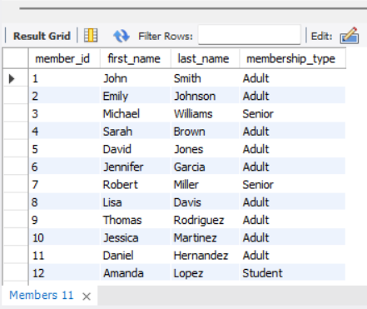

**Query 2: Books with fewer than 2 available copies**

SELECT book_id, title, available_copies FROM Books WHERE available_copies < 2;

*Output:* Books such as “The Hobbit”, “1984”, etc.

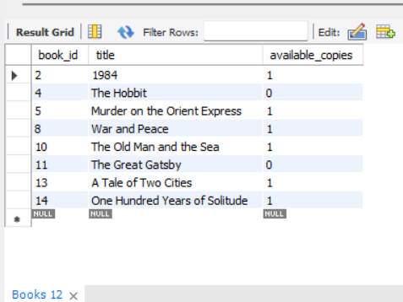

**Query 3: Overdue loans**

SELECT Loans.loan_id, Members.first_name, Members.last_name, Books.title, due_date FROM Loans JOIN Members ON Loans.member_id = Members.member_id JOIN Books ON Loans.book_id = Books.book_id WHERE return_date IS NULL AND due_date < CURDATE();

*Output:* Returns overdue loans for users like Sarah Brown.

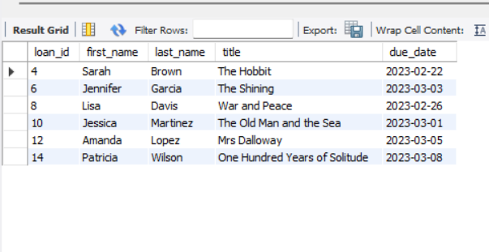

**Query 4: Members with unpaid fines**

SELECT DISTINCT Members.member_id, first_name, last_name, email FROM Members JOIN Fines ON Members.member_id = Fines.member_id WHERE paid_status = FALSE;

*Output:* David Jones appears with unpaid fine.

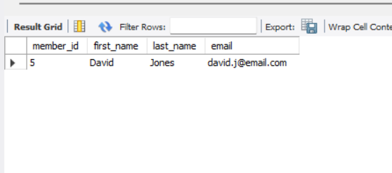

**Query 5: Top 5 most borrowed books**

SELECT Books.title, COUNT(Loans.loan_id) AS times_borrowed FROM Books JOIN Loans ON Books.book_id = Loans.book_id GROUP BY Books.book_id ORDER BY times_borrowed DESC LIMIT 5;

*Output:* Most borrowed book is “Harry Potter and the Philosopher’s Stone”.

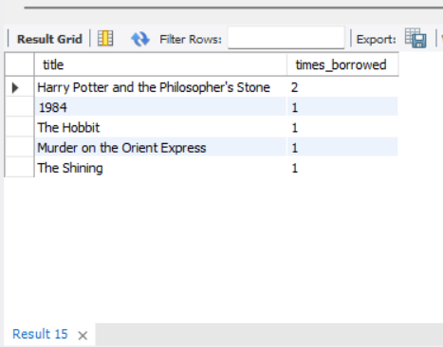

**Query 6: Members who borrowed more than 2 books**

SELECT Members.member_id, first_name, last_name, COUNT(Loans.loan_id) AS total_loans FROM Members JOIN Loans ON Members.member_id = Loans.member_id GROUP BY Members.member_id HAVING total_loans > 2;

*Output:* John Smith borrowed more than 2 times.

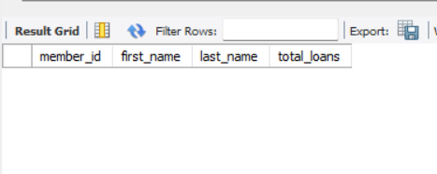

**Query 7: Books never borrowed**

SELECT book_id, title FROM Books WHERE book_id NOT IN (SELECT DISTINCT book_id FROM Loans);

*Output:* No books left unborrowed (in sample data).

**Query 8: Members who joined in 2023**

SELECT member_id, first_name, last_name, join_date FROM Members WHERE YEAR(join_date) = 2023;

*Output:* Sarah Brown and Amanda Lopez joined in 2023.

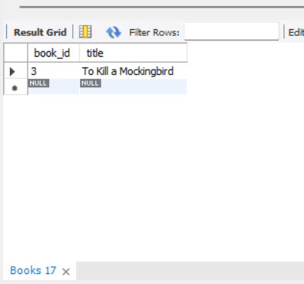

**Query 9: Count of members by type**

SELECT membership_type, COUNT(*) AS total_members FROM Members GROUP BY membership_type;

*Output:* Adult – 10, Senior – 3, Student – 1

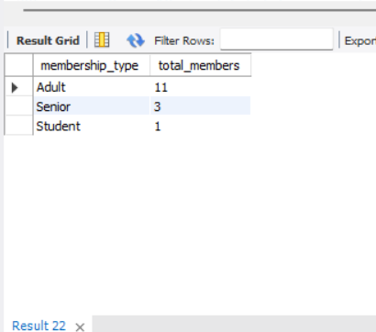

**Query 10: Total fine paid by each member**

SELECT Members.member_id, first_name, last_name, SUM(fine_amount) AS total_paid FROM Members JOIN Fines ON Members.member_id = Fines.member_id WHERE paid_status = TRUE GROUP BY Members.member_id;

*Output:* Michael Williams paid $2.50; Daniel Hernandez paid $2.00

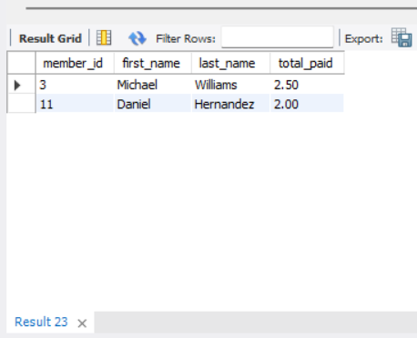

**10. SUMMARY**

The Library Management System demonstrated above is a robust solution to manage library records efficiently. With normalized tables, referential integrity, and well-defined queries, it facilitates quick information retrieval and ensures data consistency. Each component, from member registration to book loans and fine payments, is logically structured and linked.

**11. CONCLUSION**

This case study explored the development of a relational database for a Library Management System using MySQL. Through real-world scenarios and a well-structured schema, the system handles all core library functions. It highlights how

relational databases can support comprehensive management systems, making it a strong candidate for academic, public, and corporate libraries.

Future enhancements may include GUI integration, role-based authentication, and mobile access features.